NYANDENI LOCAL MUNICIPALITYT 047 555 5000 Municipality Building,E nyandeni@nyandenilm.gov.za

B.N. Nomandela Drive,www.nyandenilm.gov.za

Libode 5160 NYANDENI

# O C A L M U N I C I P A L I T Y

Building a better future the pcrsp!e

Enquiries: O. Gcaza Ext: 5061

1 3th February 2025

# NOTICE : TO ALL SPAZA SHOPS OWNERS

As we all know that the President of the Republic of South Africa has extended the closing date of Spaza shop registrations to the 28th February 2025.

This serves to remind all spaza shop owners that have not come to register to the municipality, to please come and register before the month end of February 2025.

Yours in developmental Local Government,

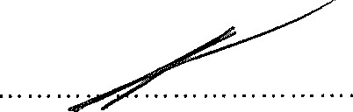

Mr. S. V. Poswa

Acting Municipal Manager